Project Design Phase-II
Data Flow Diagram & User Stories

Date | 21 February 2026
Team ID
Project Name | Darshan Ease
Maximum Marks | 4 Marks

Data Flow Diagrams:
A Data Flow Diagram (DFD) is a traditional visual representation of the information flows within a system. A neat and clear DFD can depict the right amount of the system requirement graphically. It shows how data enters and leaves the system, what changes the information, and where data is stored.
Example: DFD Level 0 (Industry Standard)
Example: (Simplified)
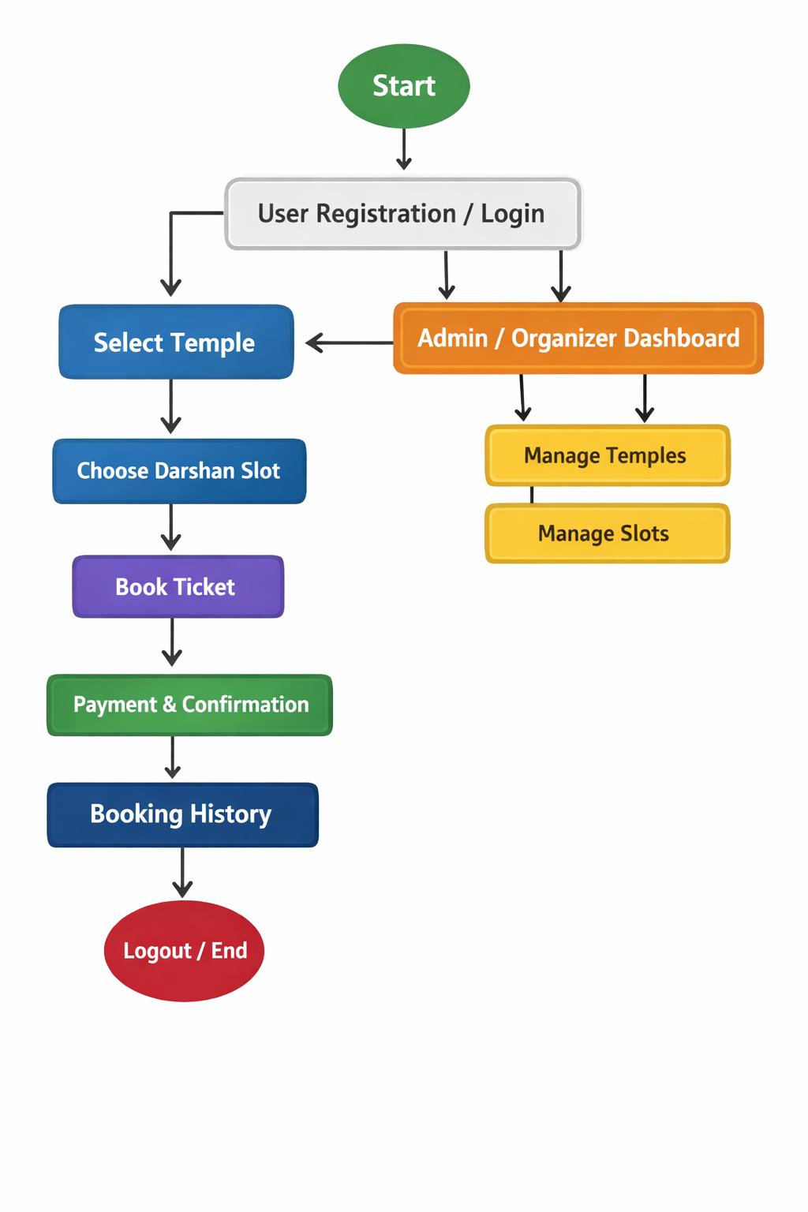


User Stories
Use the below template to list all the user stories for the product.

